
Individually

1. Using your feature list, identify where information cards may be helpful.
2. Design and build an information card component.
3. Demonstrate your information card component using content from your page.
4. Commit to your team Bitbucket repository in a folder with your name
Submit to Learnline

As I am working on creating an appointment Booking Application. There are many features that I would like to add in the application. The features are given below:
- Options for users for picking their preferred doctors.
- User can see doctors working hours and availability.
- Users can select any time unless it collides with other time.
- Users will be able to pay from their device.
- Users can also book appointment for specialist.
- Users can be able to call to all the emergency numbers when in need.
- Users can also create and login to their own account.
- Users can consult with the doctors through video call using this application

Among all the feature list we can use Information cards in the following features:-
- To show the doctors name and availability.
- To Pay for the Doctors Fees where the users can see and pay for the fees.

The first Image contains a lot of information cards which shows as a grid template. Users can see all the doctors list which appears as an information card so that they can find their preferred doctor in a very short time. It also contains the doctors image which makes it more easier and comfortable for user to find their preferred doctor
In the second image (Figure 2) we have created an card with all the relevant information which contains Doctors working days and Doctors picture in an appropriate size so that users can easily recognise their doctor by just seeing the Image. Users will also be able to Book their appointments from this card. Users can also see other doctors by clicking on see more doctors (Figure 2). The images are attached below:

Figure 1 :Doctors list card
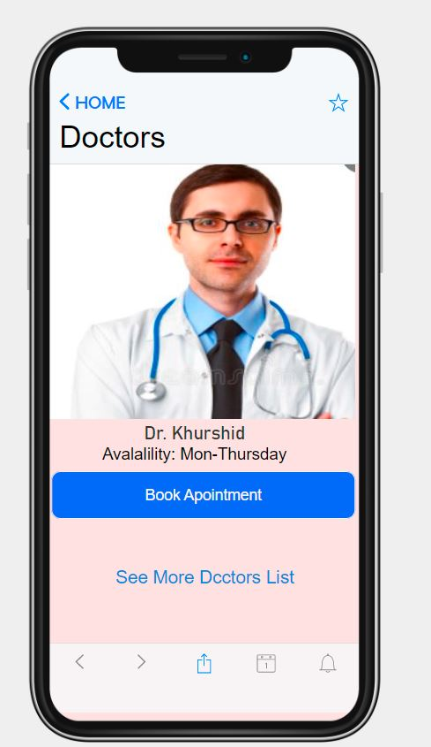
Figure 2: Doctors card
The third image is the card of payment where users can see clearly how much they need to pay to confirm the appointment. We have made the amount in red so that it becomes eye catchy and we have also highlighted the department of the doctors in red so that users can find it easy to look for their preferred doctor’s degree. We have also added search option to the top so that users can easily search by their doctors name or department if they change their mind while paying. I have coloured the search bar black so that the payment amount remains eye catchy.

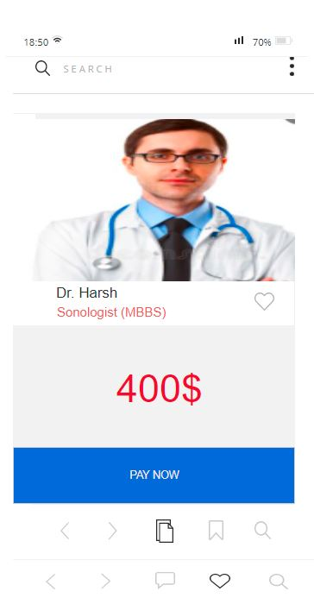
Figure 3: Payment Card

In Figure 4: I’ve coloured the title in light Blue. The image contains most portion of the screen as users can see if they are calling to their preferred doctor or not. Users will be able to call the doctors through video or audio both . the icon for the calling options is blue so that it looks stylish and eye catchy.

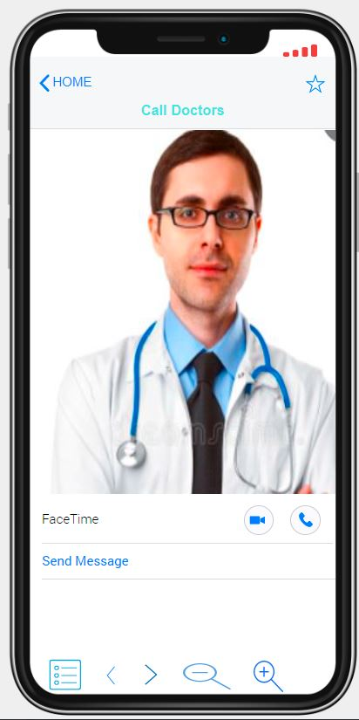
Figure 4: Calling Card

